# Lab 4.1 Upgrade the Email List application

In this exercise, you’ll upgrade the code in the Email List application so the span elements that display the error messages don’t require id attributes.

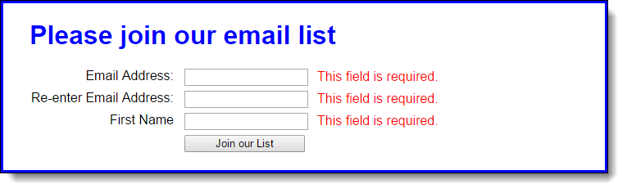

1. Open the HTML and JavaScript files in this folder:

\email_list\

Then, run the application to see that the validation works as shown above.

1. In the HTML file, delete the id attributes for the span elements.
2. In the JavaScript file, use the properties of the Node interface to display the error messages without using the id attributes.